EXPERIMENT NO. 4

1. Write a shell script that determines the period of time which is specified user is working on the system

Code:-

Echo “enter the user”

Read user

1. **Write a shell script that displays all the lines between start and end line numbers passed 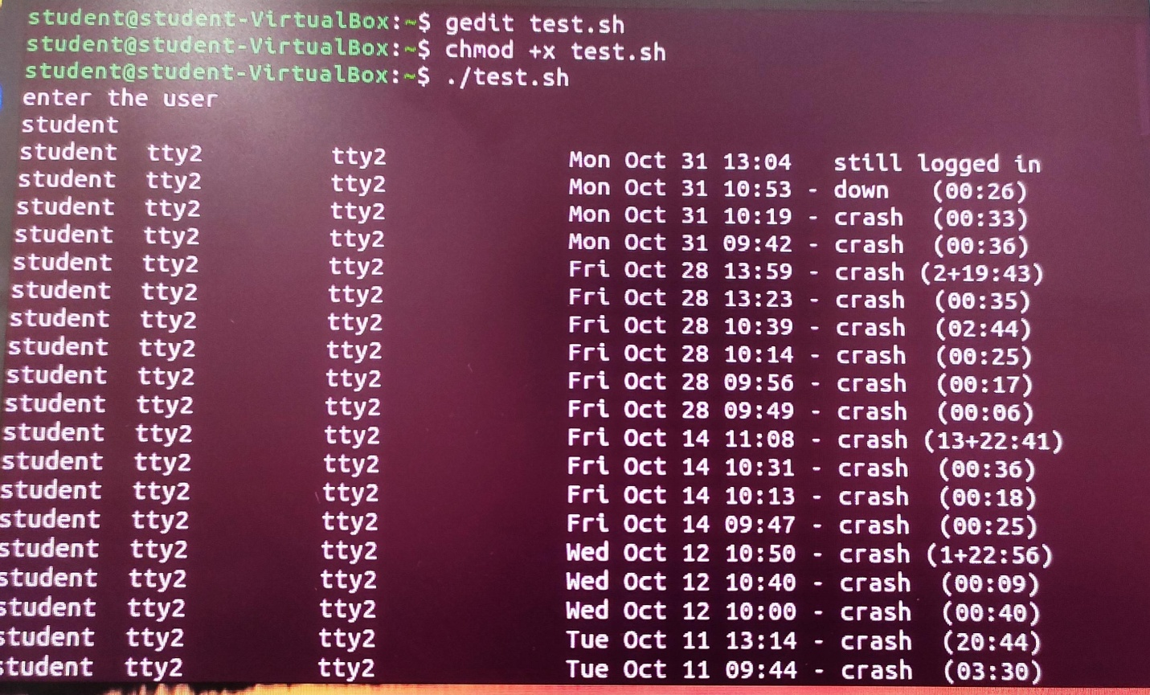as an argument**

**Code:-**

**echo “enter the file name”**

**Read file**

**Echo “enter the starting line no. “**

**Read t**

**Echo “enter the last line no. ”**

**Read n**

**Sed -n $t, $n/p $ file**

**Output:-**

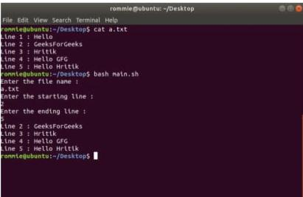

1. **Write a shell script that deletes all lines containing a specified word in one or more than line supplied as argument to it.**

**Code :-**

**Echo “enter a word “**

**Read word**

**Echo “the file name are $*”**

**For I in $\***

**Do**

**Echo “the name of the file:”$i**

**Grep -v $ word $i**

**Done**

